**Clara Deploy installation using Ansible in an Ubuntu 18.04**

Here we are going to set up Clara Deploy in Ubuntu 18.04. This setup can be used for creating clara pipeline for various use cases. The ubuntu server will host the Ansible as well, we are not remoting into the server.

For this I will be using following resource from NVIDIA

<https://ngc.nvidia.com/catalog/resources/nvidia:clara:clara_ansible>

And following resource from ansible

<https://docs.ansible.com/ansible/latest/installation_guide/intro_installation.html>

Create a g4dn ubuntu 18.04 instance in AWS

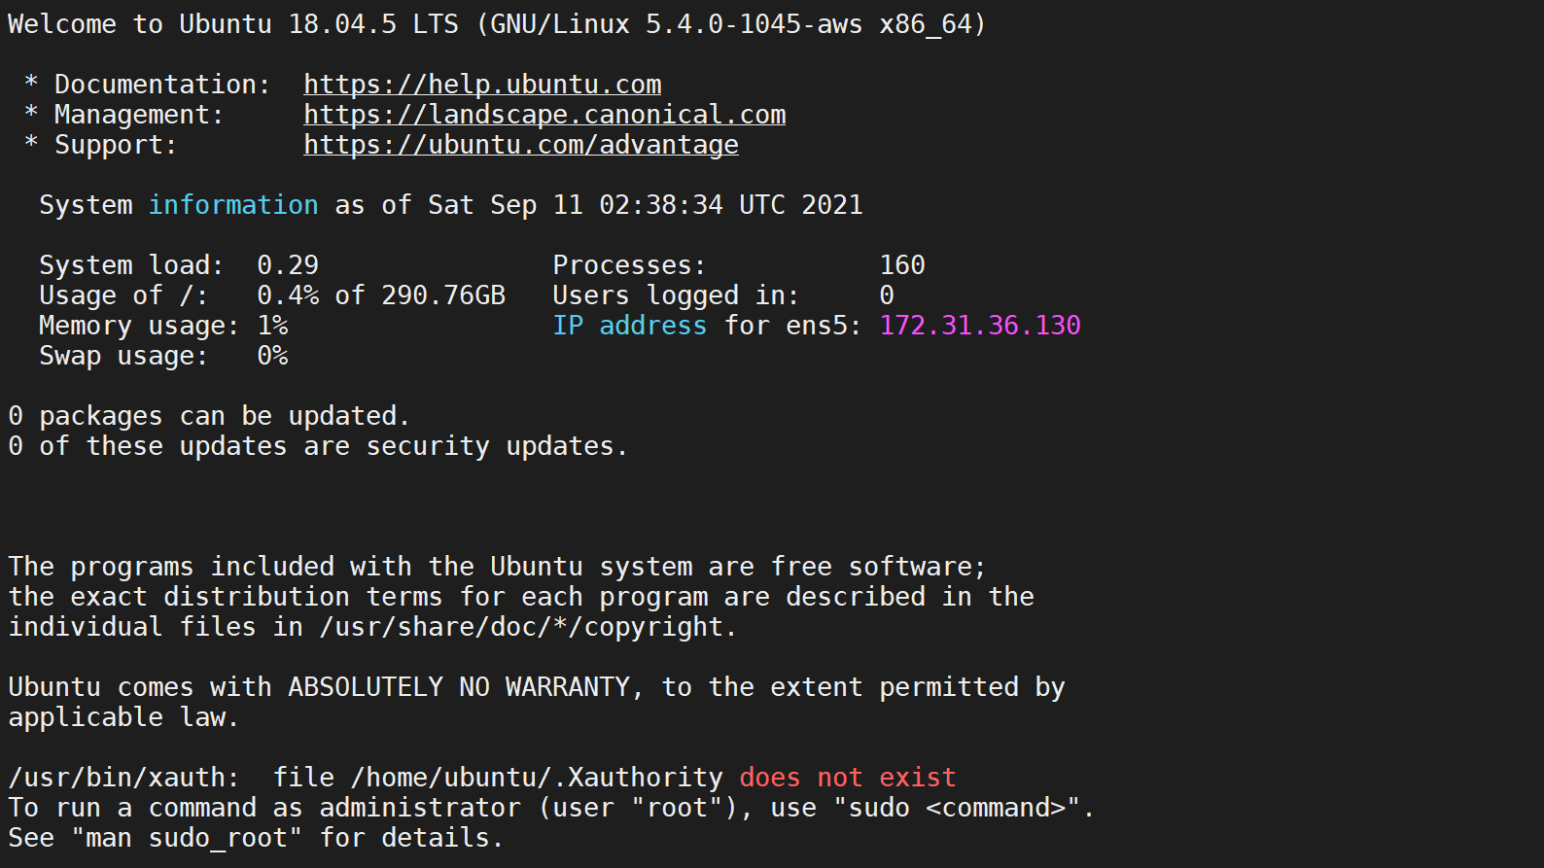

My system has python3 installed

Get the clara deploy ansible installation download from

wget --content-disposition https://api.ngc.nvidia.com/v2/resources/nvidia/clara/clara_ansible/versions/0.8.1-2108.1/zip -O clara_ansible_0.8.1-2108.1.zip

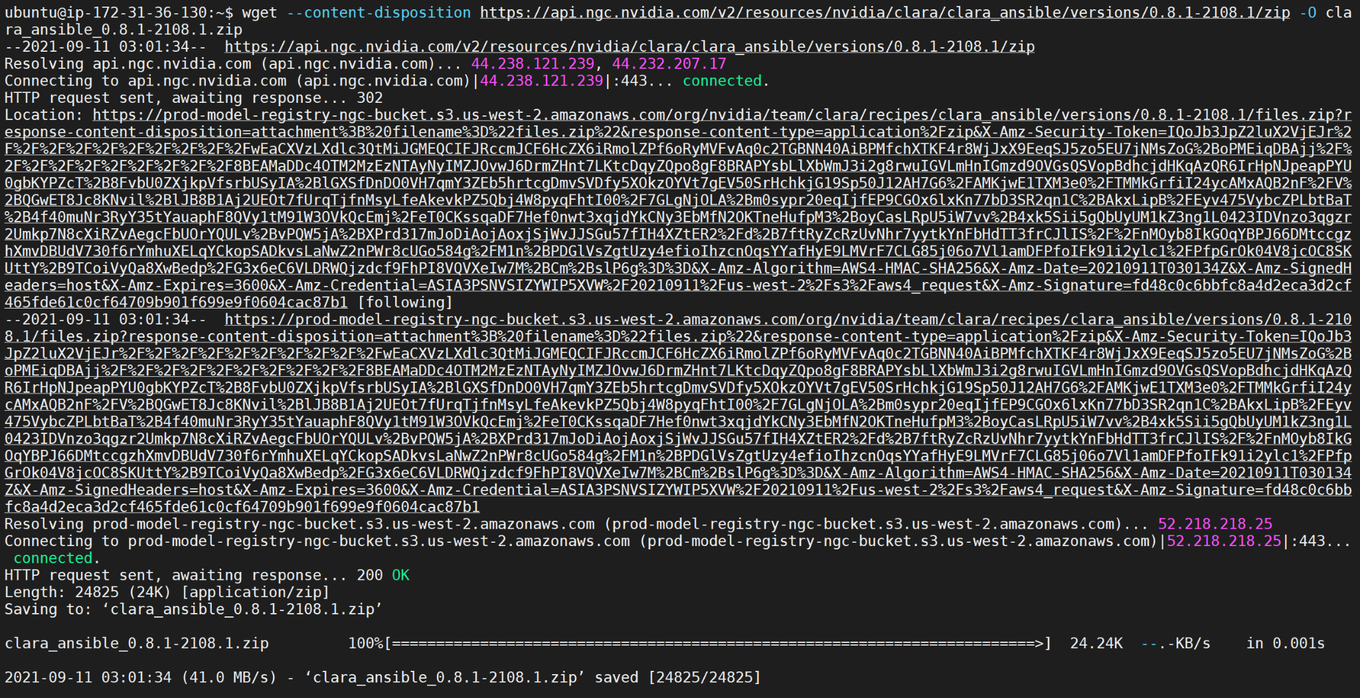

Unzip the files to get the ansible `playbook` folder. Install unzip with `sudo install unzip` if required.



My system doesn’t have Ansible installed. We can install ansible using `pip`. We can follow this process outlines in <https://docs.ansible.com/ansible/latest/installation_guide/intro_installation.html>

to install Ansible with pip.

My system doesn’t have a `pip` either. Let's start by installing pip.

$ curl https://bootstrap.pypa.io/get-pip.py -o get-pip.py



You may have to install python disutils to install additional python utilities like pip. You can do that my sudo apt-get install python3-distutils

Also install python-apt with

sudo apt-get install python3-apt

Then we can install pip

python3 get-pip.py --user

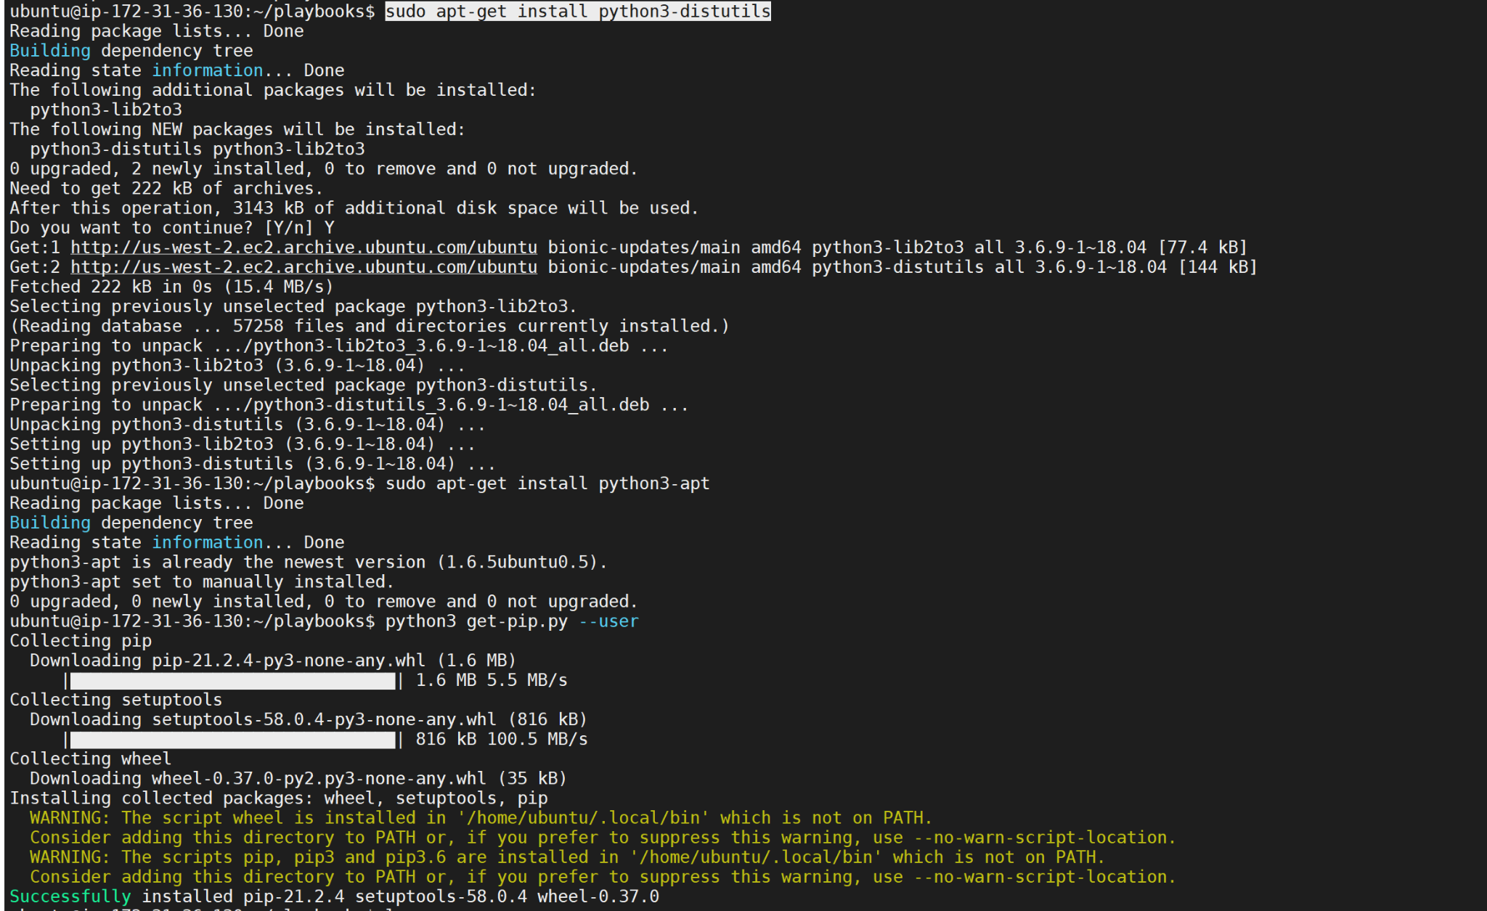

Go ahead installing ansible

python3 -m pip install --user ansible

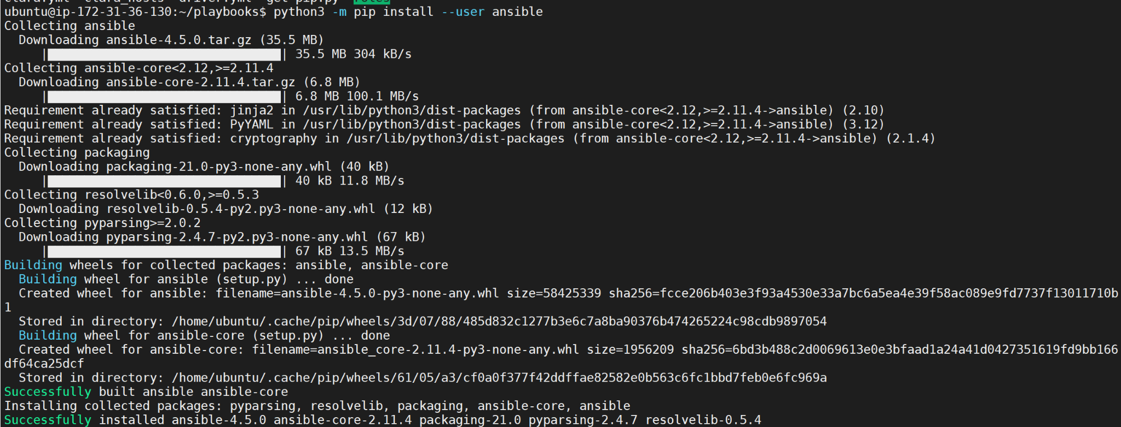

Make sure to add ansible in $PATH



Start installing NVIDIA drive from playbook



I changed the hostname to localhost as I am using the local machine for clara deploy

Do a reboot with

Sudo reboot now

Start installing clara with

Ansible-playbook -K clara.yml



Clara is installed. Check the version to ensure.

